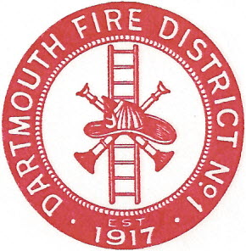
Dartmouth Fire District No.1
10 Bridge Street • Dartmouth, MA 02748
Telephone (508) 996-1596 • Fax (508) 984-4521

Agenda for September 13, 2017 @ 6:30 PM

- Vendor Warrant
- Payroll Warrant
- Building Maintenance
- Equipment Maintenance
- Bylaw changes-Clerk Ed Pimental will speak on accepted changes
- Open discussion session
- Adjourn

